- X86_32
Each process has 4G virtual address space, 0~3G for user space and 3~4G for kernel space.
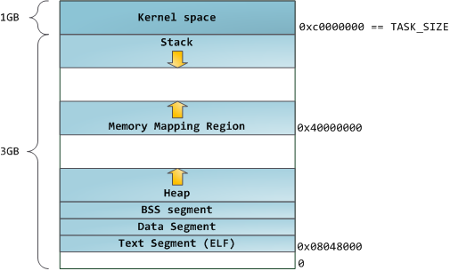
- User space
The address space in user space starts with 0G and ends with 3G.
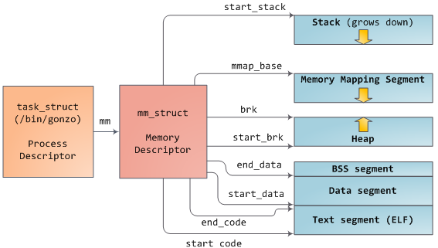
Both the mapping segment and heap area (from start_brk to mmap_base) are split into different virtual memory areas. It can be described by vm_area_struct as the follow picture.

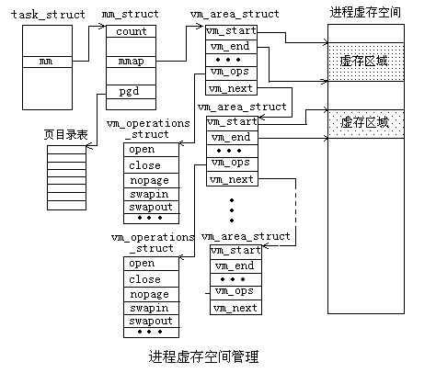
Kernel doesn’t trust the memory request of user process, so it will be delayed. The kernel only allocates a virtual memory area (virtual address space) to user process virtual memory space. When user accesses the virtual memory address first time, it arise the page fault exception and lends to allocate the frame page for the page table of this virtual address.
i. allocate
- Heap
Some virtual memory areas between start_brk and brk are created in the process started. They are reserved for the userspace malloc lib. When there is no enough space in these areas, It will call brk() to get a virtual memory area and expand the mm->brk.
do_brk(unsigned long addr, unsigned long len)
{
find_vma_links(mm, addr, addr + len, &prev, &rb_link, &rb_parent);
/* Check against address space limit. */
if (!may_expand_vm(mm, len >> PAGE_SHIFT))
return -ENOMEM;
/*
* Can we just expand an pre mapping?
*/
vma = vma_merge(mm, prev, addr, addr + len, vm_flags, NULL, file, pgoff, NULL);
if (vma)
goto out;
/*allocate a new vm_area_struct*/
vma = kmem_cache_zalloc(vm_area_cachep, GFP_KERNEL);
if (!vma) {
error = -ENOMEM;
goto unacct_error;
}

vma->vm_mm = mm;
vma->vm_start = addr;
vma->vm_end = addr + len;
vma->vm_flags = vm_flags;
vma->vm_page_prot = vm_get_page_prot(vm_flags);
vma->vm_pgoff = pgoff;

/*link the vma into mm->mmap list and rb list*/
vma_link(mm, vma, prev, rb_link, rb_parent);
}
- Mmap
unsigned long do_mmap_pgoff()
{
/*get a unmapped address*/
addr = get_unmapped_area(file, addr, len, pgoff, flags);
/*validate the parameters*/
switch (flags & MAP_TYPE) {
case MAP_SHARED:
if ((prot&PROT_WRITE) && !(file->f_mode&FMODE_WRITE))
return -EACCES;

/*
* Make sure we don't allow writing to an append-only
* file..
*/
if (IS_APPEND(inode) && (file->f_mode & FMODE_WRITE))
return -EACCES;

/*
* Make sure there are no mandatory locks on the file.
*/
if (locks_verify_locked(inode))
return -EAGAIN;

vm_flags |= VM_SHARED | VM_MAYSHARE;
if (!(file->f_mode & FMODE_WRITE))
vm_flags &= ~(VM_MAYWRITE | VM_SHARED);

/* fall through */
case MAP_PRIVATE:
if (!(file->f_mode & FMODE_READ))
return -EACCES;
if (file->f_path.mnt->mnt_flags & MNT_NOEXEC) {
if (vm_flags & VM_EXEC)
return -EPERM;
vm_flags &= ~VM_MAYEXEC;
}

if (!file->f_op || !file->f_op->mmap)
return -ENODEV;
break;

default:
return -EINVAL;
}
mmap_region(file, addr, len, flags, vm_flags, pgoff);
}

unsigned long mmap_region()
{
/*find the pre one in the rb link*/
find_vma_links(mm, addr, addr + len, &prev, &rb_link, &rb_parent);
/* Check against address space limit. */
if (!may_expand_vm(mm, len >> PAGE_SHIFT))
return -ENOMEM;
/*
* Can we just expand an pre mapping?
*/
vma = vma_merge(mm, prev, addr, addr + len, vm_flags, NULL, file, pgoff, NULL);
if (vma)
goto out;
/*allocate a new vm_area_struct*/
vma = kmem_cache_zalloc(vm_area_cachep, GFP_KERNEL);
if (!vma) {
error = -ENOMEM;
goto unacct_error;
}

vma->vm_mm = mm;
vma->vm_start = addr;
vma->vm_end = addr + len;
vma->vm_flags = vm_flags;
vma->vm_page_prot = vm_get_page_prot(vm_flags);
vma->vm_pgoff = pgoff;

if (file) {
/* call the mmap for the file of fd*/
file->f_op->mmap(file, vma);
}
/*link the vma into mm->mmap list and rb list*/
vma_link(mm, vma, prev, rb_link, rb_parent);
}

ii. accesse (page fault)
do_page_fault()
{
address = read_cr2();
if (unlikely(fault_in_kernel_space(address))) {
if (!(error_code & (PF_RSVD | PF_USER | PF_PROT))) {
if (vmalloc_fault(address) >= 0)
return;

if (kmemcheck_fault(regs, address, error_code))
return;
}
bad_area_nosemaphore(regs, error_code, address);

return;
}
}

/*for user fault*/
vma = find_vma(mm, address);
fault = handle_mm_fault(mm, vma, address, flags);
}

int handle_mm_fault()
{
/*Find the pet table of this virtual address*/
//pgd
//pud
//pmd
pte = pte_offset_map(pmd, address);
return handle_pte_fault(mm, vma, address, pte, pmd, flags);
}

int handle_pte_fault()
{
entry = *pte;
/*pte is not exist*/
if (!pte_present(entry)) {
if (pte_none(entry)) {
if (vma->vm_ops) {
if (likely(vma->vm_ops->fault))
/*fault : get the real page*/
return do_linear_fault(mm, vma, address,
pte, pmd, flags, entry);
/* ret = vma->vm_ops->fault(vma, &vmf);*/
}
/*allocate page for pte of this virtual address*/
return do_anonymous_page(mm, vma, address,
pte, pmd, flags);
}
/*for swapper*/
if (pte_file(entry))
return do_nonlinear_fault(mm, vma, address,
pte, pmd, flags, entry);
return do_swap_page(mm, vma, address,
pte, pmd, flags, entry);
}
}

int do_linear_fault()
{
vmf.virtual_address = (void __user *)(address & PAGE_MASK);
vmf.pgoff = pgoff;
vmf.flags = flags;
vmf.page = NULL;
/*assigned the page in the fault function*/
ret = vma->vm_ops->fault(vma, &vmf);
page = vmf.page;
entry = mk_pte(page, vma->vm_page_prot);
set_pte_at(mm, address, page_table, entry);
}

int do_anonymous_page()
{
……..
/*allocate a page for it*/
page = alloc_zeroed_user_highpage_movable(vma, address);
………
set_pte_at(mm, address, page_table, entry);
…….
}

- Kernel space
The address in kernel space start with PAGE_OFFSET (3G) and end with 4G

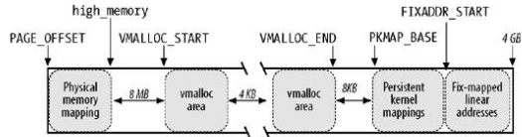

1). Physical memory mapping
min_low_pfn: the first pfn can be available in kernel
max_pfn: The last pfn can be available in kernel
max_low_pfn: the last direct mapping pfn in kernel.

void setup_arch()
{
#ifdef CONFIG_X86_32
/* calculate the direct mapping pfn , the max should be less than (VMALLOC_END - PAGE_OFFSET - __VMALLOC_RESERVE)
*/
find_low_pfn_range();
#else
/* all the memory can be direct mapping in x86_64*/
if (max_pfn > (1UL<<(32 - PAGE_SHIFT)))
max_low_pfn = e820_end_of_low_ram_pfn();
else
max_low_pfn = max_pfn;

high_memory = (void *)__va(max_pfn * PAGE_SIZE - 1) + 1;
#endif
/* direct mapping the low pfn in kernel*/
init_mem_mapping();

/*high_memory = (void *) __va(max_low_pfn * PAGE_SIZE - 1) + 1; //FOR x86_32*/
initmem_init();
}

void __init find_low_pfn_range(void)
{
if (max_pfn <= MAXMEM_PFN)
lowmem_pfn_init(); // max_low_pfn = max_pfn;
else
highmem_pfn_init(); // max_low_pfn = MAXMEM_PFN;
}

void __init init_mem_mapping(void)
{
#ifdef CONFIG_X86_64
end = max_pfn << PAGE_SHIFT;
#else
end = max_low_pfn << PAGE_SHIFT;
#endif
/*do the kernel direct mapping*/
init_range_memory_mapping(start, end);
}

- . Vmalloc space
Vmalloc is used for allocating discontinuous physical space with an continuous virtual address. The length of the vmalloc space is determined by high_memory that is decided by the real length of the physical memory. The phy_len is the length of physical memory. If phy_len is less than 896M. The high_memory is phy_len or it is 896M.
#define VMALLOC_OFFSET (8 * 1024 * 1024)
#define VMALLOC_START ((unsigned long)high_memory + VMALLOC_OFFSET)
# define VMALLOC_END (PKMAP_BASE - 2 * PAGE_SIZE)

void* vmalloc(unsigned long size);
/*the max length is VMALLOC_END - VMALLOC_START*/
$ cat /proc/meminfo
VmallocTotal: xxxxx kB

- . KMAP space
Kmap is used to mapping the physical page belong to high_memory.(the physical memory address more than 896M)
#ifdef CONFIG_X86_PAE
#define LAST_PKMAP 512
#else
#define LAST_PKMAP 1024
#endif

/*almostly 2M or 4M and for 512/1024 high memory page*/
#define PKMAP_BASE ((FIXADDR_BOOT_START - PAGE_SIZE * (LAST_PKMAP + 1)) \ & PMD_MASK)
/*It will be block for unavailable slot for map a new high_memory page*/
void *kmap(struct page *page)
void *kunmap(struct page *page)

- . FIXADDR space
FIXADDR is used for fixed map in some specific area, the length is __end_of_fixed_addresses * PAGE_SIZE.

# define KM_TYPE_NR 20
enum fixed_addresses {
#ifdef CONFIG_X86_32
FIX_HOLE,
FIX_VDSO
......
FIX_KMAP_BEGIN, /* reserved pte's for temporary kernel mappings */
FIX_KMAP_END = FIX_KMAP_BEGIN+(KM_TYPE_NR*NR_CPUS)-1,
.......
__end_of_fixed_addresses
};

#define FIXADDR_TOP 0xfffff000;
#define FIXADDR_BOOT_SIZE (__end_of_fixed_addresses << PAGE_SHIFT)
#define FIXADDR_START (FIXADDR_TOP - FIXADDR_SIZE)
#define FIXADDR_BOOT_START (FIXADDR_TOP - FIXADDR_BOOT_SIZE)

FIX_KMAP is used for temporary mapping for high_memory and there are 20 * cores pages for this mapping.
/*There is no block for the request and can be used for interupt context*/
void *kmap_atomic(struct page *page)
Void kunmap_atomic(void *kvaddr)

- X86_64
Only 48bit of 64bit physical address is used in current Linux strategy. Although virtual addresses are 64 bits wide in 64-bit mode, current implementations (and all chips known to be in the planning stages) do not allow the entire virtual address space of 2⁶⁴ bytes (16 EB) to be used. Most operating systems and applications will not need such a large address space for the foreseeable future, so implementing such wide virtual addresses would simply increase the complexity and cost of address translation with no real benefit. AMD therefore decided that, in the first implementations of the architecture, only the least significant 48 bits of a virtual address would actually be used in address translation (page table lookup). Addresses complying with this rule are referred to as "canonical form." Canonical form addresses run from 0 through 00007FFF'FFFFFFFF, and from FFFF8000'00000000 through FFFFFFFF'FFFFFFFF, for a total of 256 TB of usable virtual address space.
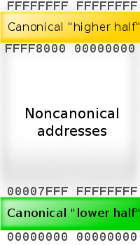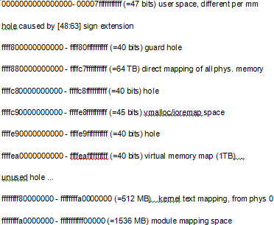
PAGE_OFFSET is ffff880000000000
64-bit Linux allows up to 256 TB of virtual address space for individual processes, 128TB for usespace and can directly mapping 64 TB of physical memory from ffff880000000000 to ffffc7ffffffffff.

